**LAB TASK No. 1**

## Task 1: Write a program that read two integers from the keyboard and print their sum and average.

**Code:**

#include<conio.h>

#include<iostream>

#include<string.h>

#include<math.h>

using namespace std;

int main()

{

int num1,num2;

cout<<"1st no. is : "<<endl;

cin>>num1;

cout<<"2nd no. is : "<<endl;

cin>>num2;

int sum;

sum = num1 + num2;

cout<<"Sum is : "<<sum<<endl;

double avg;

avg = (num1 + num2)/2;

cout<<"Average is : "<<avg<<endl;

return 0;

}

**Output:**

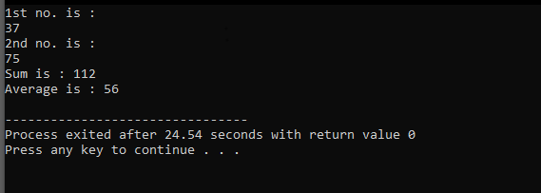

**Task 2:**Write a program that prompts for a person’s height in inches. Convert this height measurement into feet by using the conversion factor of foot2Inch= 12 inch. Now, the value obtained can easily, be translated into feet and inches which are then output by the program.

**Code:**

#include<conio.h>

#include<iostream>

#include<string.h>

#include<math.h>

using namespace std;

double feetinches(double i)

{

double f = i/12;

return f;

}

int main()

{

double ch;

cout<<"Input Inches :"<<endl;

cin>> ch;

cout<<"After Covertion feet is : "<<feetinches(ch)<<endl;

return 0;

}

**Output:**

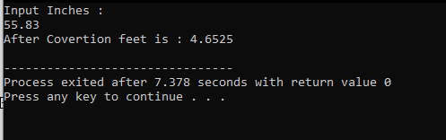

**Task 3:**Write a program that prompts for time in seconds and output that time in hours, minutes, and seconds. Here student will learn the usage of divide and modulus arithmetic operators in integers.

**Code:**

#include<conio.h>

#include<iostream>

#include<string.h>

#include<math.h>

using namespace std;

void hms(double s)

{

double i1,i2;

double hr = s/3600;

double fr1=modf(hr,&i1);

double min = fr1 * 60 ;

double fr2=modf(min,&i2);

int sec=fr2 * 60;

cout<<"Hour present: "<<i1<<endl;

cout<<"minute present : "<<i2<<endl;

cout<<"second present : "<<sec<<endl;

}

int main()

{

double sec;

cout<<"Input time in seconds "<<endl;

cin>>sec;

hms(sec);

return 0 ;

}

**Output:**

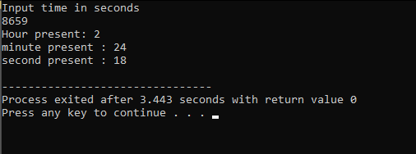

**Task 4:** Write a program that prompts for amount in rupees and show how many 1000’s, 500’s, 100’s, 50’s, 10’s, 5’s, 2’s and 1’s in it.

**Code:**

#include<conio.h>

#include<iostream>

#include<string.h>

#include<math.h>

using namespace std;

int main()

{

int a;

cout<<"Enter The amount"<<endl;

cin>>a;

int th=0;

int fh=0;

int hu=0;

int fif=0;

int te=0;

int fiv=0;

int tw=0;

int on=0;

while (a>=1000)

{

a=a-1000;

th+=1;

}

while (a>=500 && a!=0)

{

a=a-500;

fh+=1;

}

while (a>=100 && a!=0)

{

a=a-100;

hu+=1;

}

while (a>=50 && a!=0)

{

a=a-50;

fif+=1;}

while (a>=10 && a!=0)

{

a=a-10;

te+=1;}

while (a>=5 && a!=0)

{

a=a-5;

fiv+=1;}

while (a>=2 && a!=0)

{

a=a-2;

tw+=1;}

while (a>=1 && a>0)

{

a=a-1;

on+=1;

}

cout<<"No.of 1000's is : "<<th<<endl;

cout<<"No.of 500's is : "<<fh<<endl;

cout<<"No.of 100's is : "<<hu<<endl;

cout<<"No.of 50's is : "<<fif<<endl;

cout<<"No.of 10's is : "<<te<<endl;

cout<<"No.of 5's is : "<<fiv<<endl;

cout<<"No.of 2's is : "<<tw<<endl;

cout<<"No.of 1's is : "<<on<<endl;

return 0;

}

**Output:**

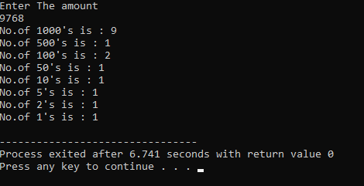

**Task 5:**Write a program that calculates the temperature in Fahrenheit. For that it prompts for temperature in Celsius degrees.Once if the task done do the vice versa.

**Code:**

#include<conio.h>

#include<iostream>

#include<string.h>

#include<math.h>

using namespace std;

ctof(double c1)

{

double f1 = (c1*(9.0/5.0))+32;

return f1;

}

ftoc(double f2)

{

double c2 = (5.0/9.0)*(f2-32);

return c2;

}

int main()

{

double fah;

double cel;

cout<<"Enter the Temperature in Celsius "<<endl;

cin>>cel;

cout<<"Temperature in Fahrenheit is :"<<ctof(cel)<<endl;

cout<<"Enter the Temperature in Fahrenheit "<<endl;

cin>>fah;

cout<<"Temperature in Celsius is :"<<ftoc(fah)<<endl;

return 0 ;

}

**Output:**

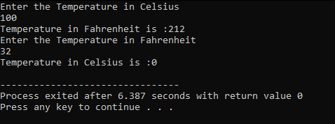

**Task 6:**Write a program that inputs a two digits integer value, and output its reverse order.

**Code:**

#include<conio.h>

#include <iostream>

#include<bits/stdc++.h>

#include<string.h>

using namespace std;

int reverse(int num)

{

static int rnum = 0;

static int base = 1;

if(num > 0)

{

reverse(num/10);

rnum += (num%10)*base;

base *= 10;

}

return rnum;

}

int main()

{

int num;

cout<<"Enter the integer"<<endl;

cin>>num;

cout << "Reverse of no. is "<< reverse(num)<<endl;

return 0;

}

**Output:**

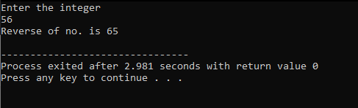

**Task 7:**Write a program that reads the two digit nmber as two characters chTen and chUnit and convert that two digit number into an integer value. In order to compute the corresponding integer value, each character must be converted to the digit in the range 0 to 9. this is done by subtracting 48(‘0’) from the ASCII value of the character.

ValueTen=chTen-‘0’; // ’8’-‘0’ is 8

ValueUnit=chUnit-‘0’; // ’2’-‘0’ is 2

To create integer value fro m, the positional value of each digit must be used. In this case multiply ValueTen by 10.

M=ValueTen*10+ValueUnit;//m=8*10+2=82

**Code:**

#include<conio.h>

#include <iostream>

#include<bits/stdc++.h>

#include<string.h>

using namespace std;

int main() {

string num;

cout<<"Enter a two digit number : "<<endl;

cin>>num;

char chTen ='num[0]';

char chUnit ='num[1]';

int Valueten =chTen - '0';

int Valueunit=chUnit-'0';

int M=Valueten*10 + Valueunit;

cout<<"Numeric Value is : "<<M<<endl;

}

**Output:**

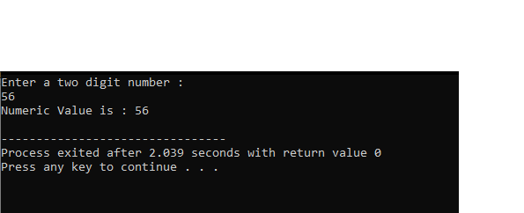

**LAB TASK No. 2**

**Task 1:**Write a program to compute the length of the line segment connecting two points.

**Code:**

#include <iostream>

#include <conio.h>

#include <string.h>

#include <math.h>

#include <cmath>

using namespace std;

int main(){

int x1,y1;

int x2,y2;

cout<<"Enter point one"<<endl;

cin>>x1>>y1;

cout<<"Enter point two"<<endl;

cin>>x2>>y2;

double distance = sqrt(pow(x2-x1,2)+pow(y2-y1,2));

cout<<"Length of line segment is : "<<distance<<"m"<<endl;

return 0;

}

**Output:**

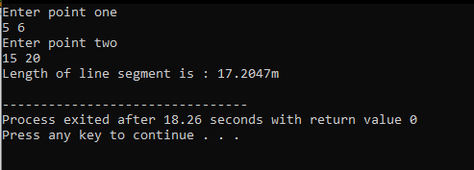

**Task 2:** Take two matrix M1 and M2 as an input and perform the addition and multiplication of these two matrices.

**Code:**

#include <iostream>

#include <conio.h>

#include <string.h>

#include <math.h>

#include <cmath>

using namespace std;

int M1[3][3];

int M2[3][3];

int M3[3][3];

int M4[3][3];

int main(){

cout<<"Matrix 1 : "<<endl;

for (int i =0 ; i<3; i++){

for (int j =0;j<3;j++){

cin>>M1[i][j];

}

}

cout<<"Matrix 2 : "<<endl;

for (int i =0 ; i<3; i++){

for (int j =0;j<3;j++){

cin>>M2[i][j];

}

}

cout << " Addition of matrix"<<endl;

for (int i =0 ; i<3; i++){

for (int j =0;j<3;j++){

M3[i][j]=M1[i][j]+M2[i][j];

cout<<M3[i][j]<<endl;

}

}

cout << " Multiplication of matrix "<<endl;

for (int i =0 ; i<3; i++)

{

for (int j =0;j<3;j++)

{

for (int k=0;k<3;k++)

{

M4[i][j]+=M1[i][k]*M2[k][j];

}

cout<<M4[i][j]<<endl;

}

}

return 0;}

**Output:**

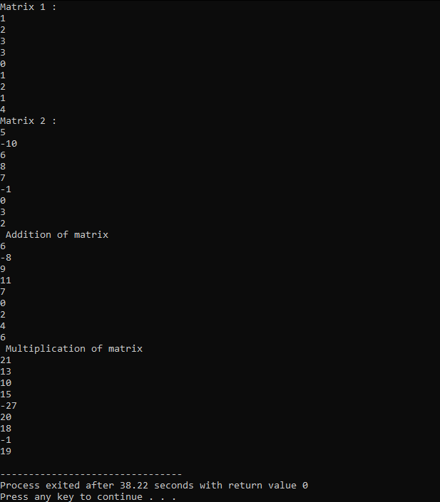

**Task 3:** Write a program that define structure to maintain student records, structure student should be consisting of the following attributes.

1. Student first name (max 20 characters) 2. Student last name (max 20 characters)

3. Student scores (float/double) e.g 85.4.

**Code:**

#include <iostream>

#include <conio.h>

#include <string.h>

#include <math.h>

#include <cmath>

using namespace std;

struct student

{

char fname[20] ;

char lname[20];

double gpa;

};

int main()

{

student st;

cout<<"Enter First name"<<endl;

cin.get(st.fname,20);

cin.get();

cout<<"Enter Last name"<<endl;

cin.get(st.lname,20);

st.gpa = 3.08;

cout<<"Student's first name :"<<st.fname<<endl;

cout<<"Student's last name :"<<st.lname<<endl;

cout<<"Student GPA :"<<st.gpa<<endl;

return 0;

}

**Output:**

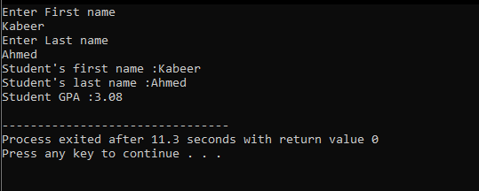

**Task 4:** Pass the structure define in Q.3 to some function to move to display.

**Code:**

#include <iostream>

#include <conio.h>

#include <string.h>

#include <math.h>

#include <cmath>

using namespace std;

struct student

{

char fname[20] ;

char lname[20];

double gpa;

};

void showdata(student s)

{

cout<<"Enter First name"<<endl;

cin.get(s.fname,20);

cin.get();

cout<<"Enter Last name"<<endl;

cin.get(s.lname,20);

s.gpa = 3.08;

cout<<"Student's first name :"<<s.fname<<endl;

cout<<"Student's last name :"<<s.lname<<endl;

cout<<"Student GPA :"<<s.gpa<<endl;

}

int main()

{

student st;

showdata(st);

return 0;

}

**Output:**

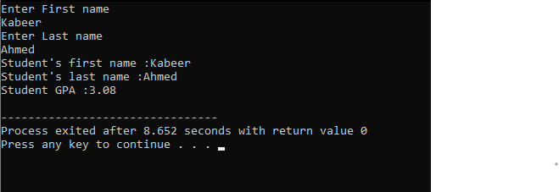

**Task 5:** Create nested structure . Firstly define Address structure and then call address

Structure in Employee Structure and program will give some raise in salary ,if it is less than 50000

Address (house no, city, pin code)

Employee (empid,name,salary,address)

**Code:**

#include <iostream>

#include <conio.h>

#include <string.h>

#include <math.h>

#include <cmath>

using namespace std;

struct Address

{

char HouseNo[20];

char City[20];

char PinCode[20];

};

struct Employee

{

int Id;

char Name[15];

float Salary;

struct Address Add;

};

int increment(Employee sl)

{

sl.Salary+=2000;

return sl.Salary;

}

int main()

{

int i;

Employee Emp;

cout << "Enter Employee Id : ";

cin >> Emp.Id;

cout << "\nEnter Employee Name : ";

cin >> Emp.Name;

cout << "\nEnter Employee Salary : ";

cin >> Emp.Salary;

cout << "\nEnter Employee House No : ";

cin >> Emp.Add.HouseNo;

cout << "\nEnter Employee City : ";

cin >> Emp.Add.City;

cout << "\nEnter Employee Pin code : ";

cin >> Emp.Add.PinCode;

cout << "\n\tDetails of Employees";

cout << "\nEmployee Id : " << Emp.Id;

cout << "\nEmployee Name : " << Emp.Name;

cout << "\nEmployee Salary : " << Emp.Salary;

if(Emp.Salary<=50000)

{

cout<<"\n\t Incremented salary :"<<increment(Emp);

}

cout << "\nEmployee House No : " << Emp.Add.HouseNo;

cout << "\nEmployee City : " << Emp.Add.City;

cout << "\nEmployee Pin Code : " << Emp.Add.PinCode;

return 0;

}

**Output:**

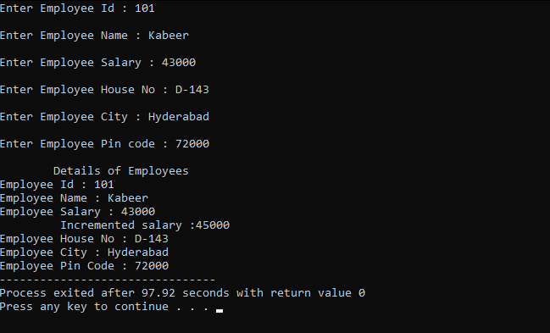

**Task 6:** Write a C++ Program to create a small Calculator by using Pointers.

**Code:**

#include <iostream>

#include <conio.h>

#include <string.h>

#include <math.h>

#include <cmath>

using namespace std;

int add(int *p1,int *p2)

{

return *p1 + *p2;

}

int sub(int *p1,int *p2)

{

return *p1 - *p2;

}

int multiply(int *p1,int *p2)

{

return *p1 * *p2;

}

int divide(int *p1,int *p2)

{

return *p1 / *p2;

}

int main()

{

int num1 , num2;

cout<<"number 1:"<<endl;

cin>>num1;

cout<<"number 2:"<<endl;

cin >> num2;

int *p1 ,*p2;

p1=&num1;

p2=&num2;

char dir = '0';

cout<<"\tCalculator"<<endl;

cout<<"Press Keys :: s = + , m = - , M=* d=/ "<<endl;

dir=_getch();

if(dir=='s')

{

cout<<"Addition of the two numbers are : "<<add(p1,p2);

}

else if(dir=='m')

{

cout<<"Subtraction of the two numbers are : "<<sub(p1,p2);

}

else if(dir=='M')

{

cout<<"Multiplication of the two numbers are : "<<multiply(p1,p2);

}

else if(dir=='d')

{

cout<<"Division of the two numbers are : "<<divide(p1,p2);

}

else

{

cout<<"Operation is out of range";

}

return 0;

}

**Output:**

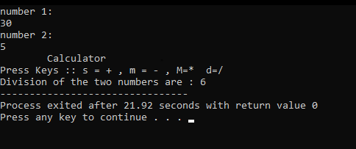

**LAB TASK No. 3**

**Task 1:** write a program in C++ that can calculate the factorial of a number by passing the address of that number to a function,using pointers.

**Code:**

#include <iostream>

#include <conio.h>

#include <string.h>

#include <math.h>

#include <cmath>

using namespace std;

int fact(int *p)

{

int factorial=1;

while(*p>1)

{

factorial*=*p;

*p=*p-1;

}

return factorial;

}

int main()

{

int num,*p;

cout<<"Enter the Number : ";

cin>>num;

p=&num;

cout <<"Factorial of Number is : "<<fact(p);

return 0;

}

**Output:**

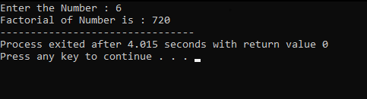

**Task 2:** Write down a C++ program that will declare and initialize two arrays and would generate the sum of these two arrays by using pointers.

**Code:**

#include <iostream>

#include <conio.h>

#include <string.h>

#include <math.h>

#include <cmath>

using namespace std;

void sum(int *p1,int *p2)

{

int c[5];

int *sum =c;

cout<<"Sum of the Array is"<<endl;

for (int i=0;i<5;i++)

{

*sum = *p1 + *p2;

cout<<*sum<<endl;

*p1++;

*p2++;

}

}

int main()

{

int *p1,*p2;

int arr1[]={1,2,3,4,5};

int arr2[]={6,7,8,9,10};

p1=arr1;

p2=arr2;

sum(p1,p2);

return 0;

}

**Output:**

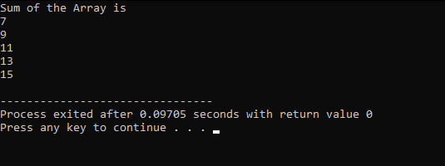

**Task 3:** Write down a C++ program, that will Calculate the area of a Circle by using Constant Data member PI=3.14, and by using Constant Pointer.

**Code:**

#include <iostream>

#include <conio.h>

#include <string.h>

#include <math.h>

#include <cmath>

using namespace std;

int main()

{

int radius =8;

int pivalue = 3.14;

const int *const ptr2 = &radius;

cout << "Area of circle "<<endl;

cout<< *ptr2 * pow(radius,2);

return 0;

}

**Output:**

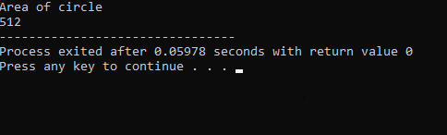

**Task 4:** Write down a C++ program that would generate some table 2*1=2,2*10=20by using pointers.

**Code:**

#include <iostream>

#include <conio.h>

#include <string.h>

#include <math.h>

#include <cmath>

using namespace std;

int main()

{

int num;

int *p;

cout<<"Enter the Table Number :";

cin>>num;

cin.get();

p=&num;

for (int i =1 ; i<11; i++)

{

cout<< *p <<" * "<<i<<" = "<<*p * i<<endl;

}

return 0;

}

**Output:**

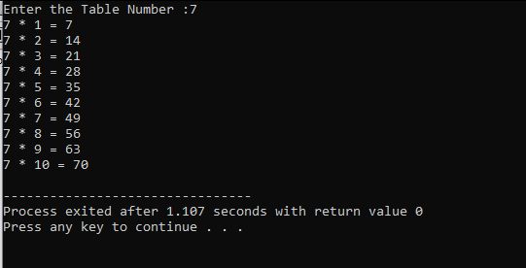

**Task 5:** Write down a C++ program that would design a simple Calculator, by using Pointers.

**Code:**

#include <iostream>

#include <conio.h>

#include <string.h>

#include <math.h>

#include <cmath>

using namespace std;

int add(int *p1,int *p2)

{

return *p1 + *p2;

}

int sub(int *p1,int *p2)

{

return *p1 - *p2;

}

int multiply(int *p1,int *p2)

{

return *p1 * *p2;

}

int divide(int *p1,int *p2)

{

return *p1 / *p2;

}

int main()

{

int num1 , num2;

cout<<"number 1:"<<endl;

cin>>num1;

cout<<"number 2:"<<endl;

cin >> num2;

int *p1 ,*p2;

p1=&num1;

p2=&num2;

char dir = '0';

cout<<"\tCalculator"<<endl;

cout<<"Press Keys :: s = + , m = - , M=* d=/ "<<endl;

dir=_getch();

if(dir=='s')

{

cout<<"Addition of the two numbers are : "<<add(p1,p2);

}

else if(dir=='m')

{

cout<<"Subtraction of the two numbers are : "<<sub(p1,p2);

}

else if(dir=='M')

{

cout<<"Multiplication of the two numbers are : "<<multiply(p1,p2);

}

else if(dir=='d')

{

cout<<"Division of the two numbers are : "<<divide(p1,p2);

}

else

{

cout<<"Operation is out of range";

}

return 0;

}

**Output:**



**LAB TASK No. 4**

**Task 1:** Create the object of the flight class and apply the defined methods.

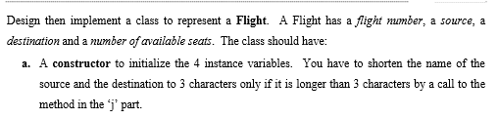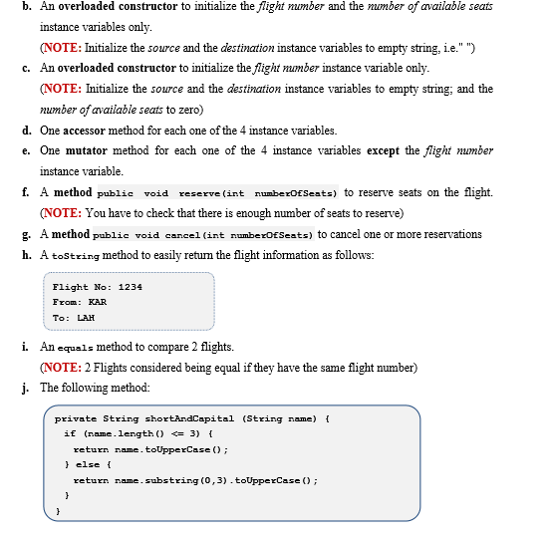

**Code:**

#include <iostream>

#include <conio.h>

#include <string>

#include <math.h>

#include <cmath>

#include <iostream>

#include <string>

using namespace std;

class Flight

{

int cance;

int reserv;

string source;

string destination;

int avaSeats;

int flightNo;

public:

Flight(string s,string d,int ava , int fNo): source(s),destination(d),avaSeats(ava),flightNo(fNo){ }

Flight(int ava , int fNo)

{

source=" ";

destination=" ";

avaSeats=ava;

flightNo=fNo;

}

Flight(int fNo)

{

source=" ";

destination=" ";

avaSeats=0;

flightNo=fNo;

}

void setSource(string s)

{

source=s;

}

void setDestination(string d)

{

destination=d;

}

void setSeats(int a)

{

avaSeats=a;

}

void setflight(int f)

{

flightNo=f;

}

string getSource()

{

return source;

}

string getDestination()

{

return destination;

}

int getSeats(){

return avaSeats;

}

int getflight(){

return flightNo;

}

int reserve(int numberofseat){

reserv=numberofseat;

avaSeats-=reserv;

return avaSeats;

}

int cancel(int numberofseats){

cance=numberofseats;

avaSeats+=cance;

return cance;

}

void equals(int f, int f1){

if (f==f1){

cout<< "\n\tequal flights";

}

}

void tostring(string s,string d, int fNo){

cout<<"\n\t Flight No : "<< fNo;

for(int i=0;i<=3;i++)

{

if(s[i]>=97 && s[i]<=122)

{

s[i]=s[i]-32;

}

if(d[i]>=97 && d[i]<=122)

{

d[i]=d[i]-32;

}

}

cout<<"\n\t Source : "<<s[0]<<s[1]<<s[2];

cout<<"\n\t Destination : "<<d[0]<<d[1]<<d[2]<<endl;

}

};

int main()

{

Flight f1("Karachi","Hyderabad",747,123);

Flight f2("Lahore","Islamabad",747,124);

int f1fl= f1.getflight();

string f1s= f1.getSource();

string f1d=f1.getDestination();

int f2fl= f2.getflight();

string f2s= f2.getSource();

string f2d=f2.getDestination();

cout<<"\n\t FLight 1:";

cout<<"\n\t Enter flight no :"<<f1.getflight();

int nseats,nseats1;

cout<<"\n\t Enter no. of seats ";

cin>>nseats;

cout<<"\t Enter Source :"<<f1.getSource();

cout<<"\n\t Enter Destination :"<<f1.getDestination();

cout<<"\n\t Reserve seats : "<< nseats;

cout<<"\n\t Available seats : "<< f1.reserve(nseats)<<endl;

cout<<"\n\t FLight 2 :";

cout<<"\n\t Enter flight no :"<<f2.getflight();

cout<<"\n\t Enter no. of seats ";

cin>>nseats1;

cout<<"\t Enter Source :"<<f2.getSource();

cout<<"\n\t Enter Destination :"<<f2.getDestination();

cout<<"\n\t Reserve seats : "<< nseats1;

cout<<"\n\t Available seats : "<< f2.reserve(nseats1)<<endl;

cout<<"\n\t FLight 1 INFO :";

f1.tostring(f1s,f1d,f1fl);

cout<<"\n\t FLight 2 INFO :";

f2.tostring(f2s,f2d,f2fl);

f1.equals(f1fl,f2fl);

return 0;

}

**Output:**

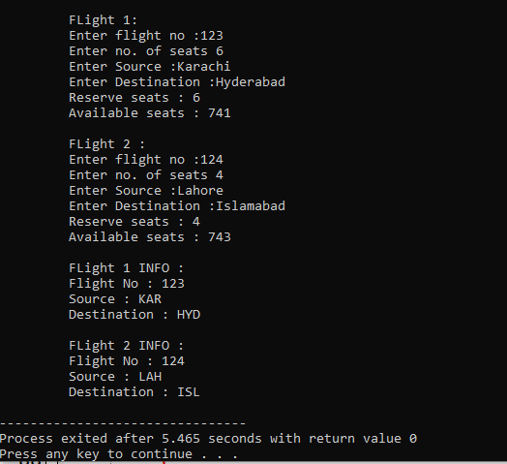

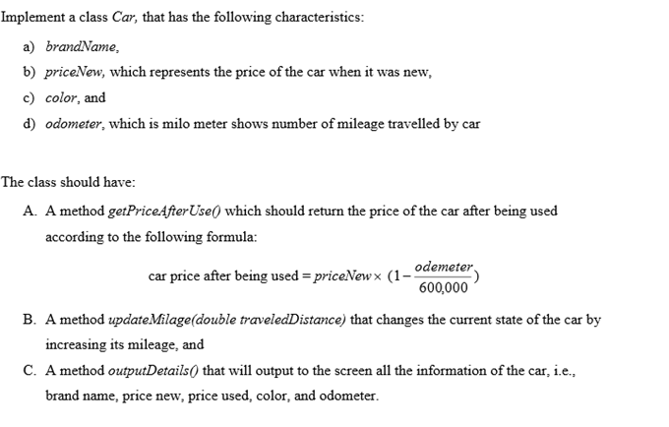**Task 2:**

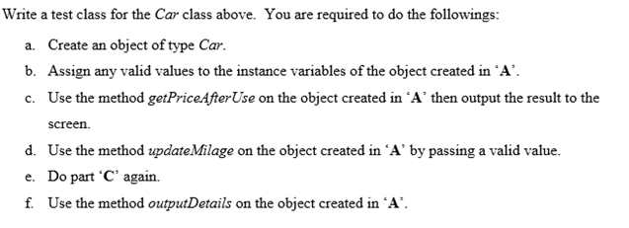

**Code:**

#include <iostream>

#include <conio.h>

#include <string>

#include <math.h>

#include <cmath>

using namespace std;

class Car{

string brandname;

double priceNew;

string color;

double odometer;

public:

Car(string b , double p,string c,double o) : brandname(b), priceNew(p),odometer(o),color(c) { }

int getpriceafteruse(double o,double pp){

double use = pp * (1 - (o/6000));

return use;

}

int updatedodometer(double o){

odometer+=o;

return o;

}

int outputdetails(string b , double pn, double pu,string c ,double o){

cout<< "\n\tCar info :";

cout<< "\nBrand Name :"<<b;

cout<< "\nNew Price :"<<pn;

cout<< "\nColour :"<<c;

cout<< "\nOdometer :"<<o;

cout<< "\nPrice after use :"<<pu;

}

};

int main(){

string b;

double p;

string c;

double o;

double oo;

cout<< "\nEnter Brand "<<endl;

cin>>b;

cout<< "\nEntercolour "<<endl;

cin>>c;

cout<< "\nEnter New Price "<<endl;

cin>>p;

cout<< "\nEnter Odometer "<<endl;

cin>>o;

Car cc(b,p,c,o);

cout<< "\nCar Price after use : ";

cout<<cc.getpriceafteruse(o,p);

cout<< "\nEnter New Odometer: ";

cin>>oo;

double up=cc.updatedodometer(oo);

double pu=cc.getpriceafteruse(up,p);

cout<< "\nCar Price after use : "<<cc.getpriceafteruse(up,p)<<endl;

cc.outputdetails(b,p,pu,c,up);

return 0;

}

**Output:**

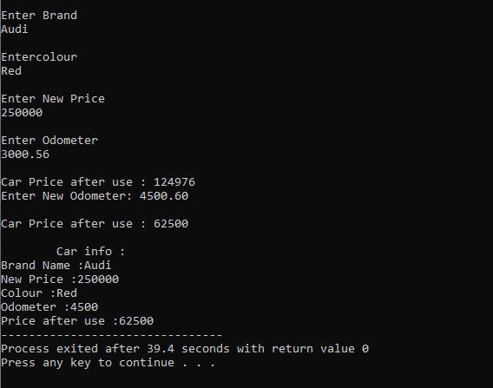

**Task 3:**

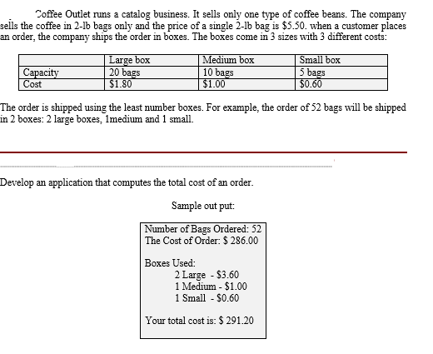

**Code:**

#include <iostream>

#include <conio.h>

#include <string>

#include <math.h>

#include <cmath>

using namespace std;

class Coffee

{

int total;

int big ;

int medium ;

int small ;

public:

void div(int t)

{

double tt=t*5.50;

cout<<"\nThe cost of order : $"<<tt;

total=t;

cout<<"\nTotal boxes used: "<<endl;

while(total>=20)

{

big+=1;

total-=20;

}

double bigt = big*1.80;

cout<<"\t"<<big<<"Large - $"<<bigt<<endl;

while(total>=10 && total<20)

{

medium+=1;

total-=10;

}

double mt = medium*1.00;

cout<<"\t"<<medium<<"Medium - $"<<mt<<endl;

while(total>=5 || (total<=5 && total>0))

{

small+=1;

total-=5;

}

double st = small*0.60;

cout<<"\t"<<small<<"Small - $"<<st<<endl;

cout<<"\n\t The Total cost is : $"<<tt+st+mt+bigt;

}

};

int main(){

Coffee cf;

int bag;

cout<<"\nEnter total no.of coffee bags :"<<endl;

cin>>bag;

cf.div(bag);

return 0;

}

**Output:**

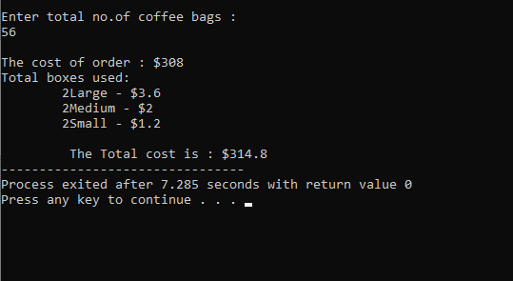

**LAB TASK No. 5**

**Task 1:**A company called Restaurant Products, Inc. wants to produce small machines for use by waiters in a restaurant. Each machine is initialized with the name of the restaurant and the local sales tax rate. When a customer has finished eating, the waiter enters the cost of the meal and has the machine output a bill in the following form:

To produce the software for this machine write down the class description and declaration for the MealBill class.

**Code:**

#include <iostream>

#include <conio.h>

#include <string.h>

#include <math.h>

#include <cmath>

using namespace std;

class MealBill

{

double tcost;

int tax;

double tip;

public:

void bill(double meal)

{

tax=meal *0.25;

tip= meal * 0.15;

tcost=tip+meal+tax;

cout<<"\n\t Meal Cost : "<<meal;

cout<<"\n\t Tax : "<<tax;

cout<<"\n\t Tip : "<<tip;

cout<<"\n\t total Cost : "<<tcost;

}

void reciept(double p)

{

cout<<"\n\t total Cost : "<<tcost;

cout<<"\n\t Payment : "<<p;

cout<<"\n\t Change : "<<p-tcost;

cout<<"\n\t Thank You for dining at Royal Taj restaurant";

}

};

int main()

{

MealBill M;

double m;

double r;

cout<<"Enter the cost for the meal"<<endl;

cin>>m;

cout<<"\n\t Preview for bill";

M.bill(m);

cout<<"\nEnter the amount paid by the customer"<<endl;

cin>>r;

M.reciept(r);

return 0;

}

**Output:**

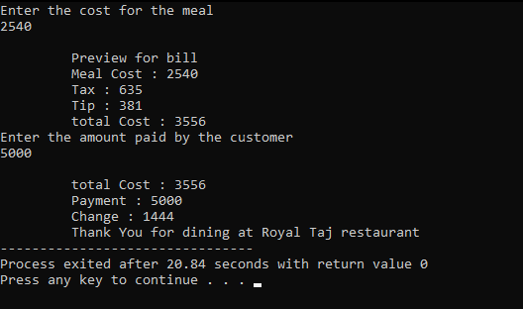

**Task 2:**Write a program for The University Summit Restaurant, which allows a student Ahmed Ali to charge the cost of a meal to his student account. Records are stored in the student account object ahmedAli that has a current balance of Rs.2000.00. The Summit Restaurant implements billing by creating a MealBill object, which is set to charge 6% sales tax. The program first prompts for the cost of the meal and then computes and prints the bill. It then makes a charge to the student’s account and prints the receipt. In the end the program prints the current status of Ahmed’s account.

**Code:**

#include <iostream>

#include <conio.h>

#include <string.h>

#include <math.h>

#include <cmath>

using namespace std;

class studentBill

{

double tcost;

int tax;

double tip;

public:

string name;

string aname;

studentBill(string n,string a ): name(n),aname(a) { }

void bill(double meal)

{

tax=meal *0.06;

tip= meal * 0.15;

tcost=tip+meal+tax;

cout<<"\n\t Meal Cost : "<<meal;

cout<<"\n\t Tax : "<<tax;

cout<<"\n\t Tip : "<<tip;

cout<<"\n\t total Cost : "<<tcost;

}

void reciept(double p)

{

cout<<"\n\t total Cost : "<<tcost;

cout<<"\n\t Payment : "<<p;

cout<<"\n\t Change : "<<p-tcost;

cout<<"\n\t Thank You for dining at Royal Taj restaurant";

cout<<"\n\t Student name :"<<name;

cout<<"\n\t Student Bank account number :"<<aname;

cout<<"\n\t Student remaining rupees in the account :"<<p-tcost;

}

};

int main()

{

studentBill st("Kabeer Ahmed","4201750");

double a = 2000;

cout<<"Money present in the account is :"<<a<<endl;

double m;

cout<<"Enter the cost for the meal"<<endl;

cin>>m;

cout<<"\n\t Preview for bill";

st.bill(m);

cout<<"\nAmount paid by student account"<<a<<endl;

st.reciept(a);

return 0;

}

**Output:**

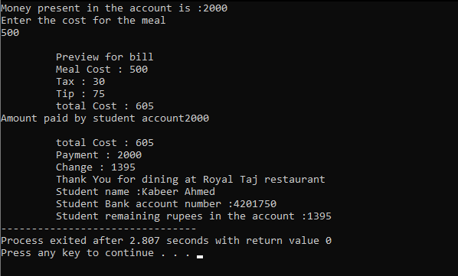

**Task 3:**A student’s grade record is maintained by the registrar in the Academic Dept. The record includes the studentID along with the total number of credits attempted and the total grade points earned by the student. The grades points are determined by the scale A(4), B(3), C(2), D(1), and F(0).

**Code:**

#include <iostream>

#include <conio.h>

#include <string.h>

#include <math.h>

#include <cmath>

using namespace std;

class gpa

{

string name;

string id;

double GPA;

char gp;

int credit ;

int points;

public :

gpa()

{

gp=NULL;

credit=0;

points=0;

}

gpa(string n , string i, double G , int p , int c) : name(n), id(i) , GPA(G), credit(c), points(p) { }

char AP(char g)

{

switch(g)

{

case 'A':

return 4*4;

break;

case 'B':

return 4*3;

break;

case 'C':

return 4*2;

break;

case 'F':

return 4*0;

break;

}

}

int oop(char g)

{

switch(g)

{

case 'A':

return 4*4;

break;

case 'B':

return 4*3;

break;

case 'C':

return 4*2;

break;

case 'F':

return 4*0;

break;

}

}

int SE(char g)

{

switch(g)

{

case 'A':

return 3*4;

break;

case 'B':

return 3*3;

break;

case 'C':

return 3*2;

break;

case 'F':

return 3*0;

break;

}

}

int ARW(char g)

{

switch(g)

{

case 'A':

return 2*4;

break;

case 'B':

return 2*3;

break;

case 'C':

return 2*2;

break;

case 'F':

return 2*0;

break;

}

}

void show()

{

cout<<" \n Student name : "<<name;

cout<<"\tId : "<<id;

cout<<"\tUnits : "<<credit;

cout<<"\tPoints : "<<points;

cout<<"\tGPA : "<<GPA;

}

};

int main()

{

cout<<"\n\t Students Gpa preview";

cout<<"\n\t Existing Students record Shown as";

gpa gg("Taha","SE-19021",2.8,25,8 );

gg.show();

gpa gg1;

int oo=gg.oop('A');

int ap=gg.AP('C');

int se=gg.SE('B');

int arw=gg.ARW('A');

cout<<"\n\t New student record shown";

cout<<" \n Student name : Kabeer";

cout<<"\tId : SE-19028";

cout<<"\tUnits : "<<(oo+ap+se+arw)/4;

cout<<"\tPoints : "<<oo+ap+se+arw;

cout<<"\tGPA : "<<3.08;

return 0;

}

**Output:**

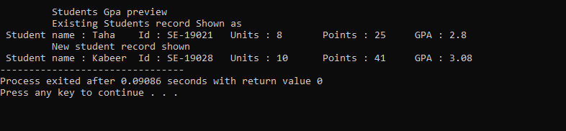

**Task 4:**Write a program that creates a student grade record for a new student. To indicate that student is new print the students initial grade point average. The program then prompts for the grade points and credits that the student has earned in the first semester and updates his/her grade record. The student’s record at the end of the semester is then output to the screen.

**Code:**

#include <iostream>

#include <conio.h>

#include <string.h>

#include <math.h>

#include <cmath>

using namespace std;

class unistd

{

string name;

string id;

double GPA;

int credit ;

int points;

public:

unistd(string n , string i)

{

cout<<"\n\t New student ";

cout<<"\n Student name"<<n;

cout<<"\t Id"<<i;

cout<<"\t Gpa"<<0.0;

cout<<"\t Student credits"<<0;

cout<<"\t points"<<0;

}

unistd(string n , string i, double G , int p , int c)

{

cout<<"\n\t Existing student score in this semester ::";

cout<<"\n Student name"<<n;

cout<<"\t Id"<<i;

cout<<"\t Gpa"<<G;

points=p;

credit=c;

cout<<"\t Student credits"<<c;

cout<<"\t points"<<p;

}

void updated(int p , int c)

{

cout<<"\nNew Student's score in this semester ::";

cout<<"\t Student credits"<<c+credit;

cout<<"\t points"<<p+points;

}

};

int main(){

unistd s1("Rehan","SE-19036");

unistd s2("Kabeer","SE-19028",3.9,52,13);

int n1,n2;

cout<<"\n\tEnter credits and points for this semester ";

cin>>n1>>n2;

s2.updated(n2,n1);

return 0;

}

**Output:**

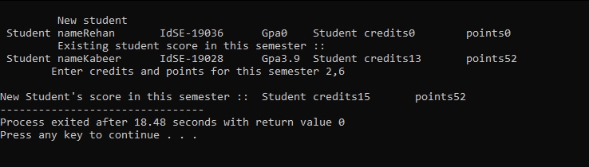

**Task 5:** Create a Base Class Person having attributes( name,age,gender) with behavior of showdata(displaying all the members) and override same method in derived classes.Derive student Class and from student class derive graduate student with appropriate data members and behavior.

**Code:**

#include <iostream>

#include <conio.h>

#include <string.h>

#include <math.h>

#include <cmath>

using namespace std;

class person

{

protected:

string name;

int age ;

char gender ;

public:

void show()

{

cout<<"\n\t Base Class";

cout<<"\n\t Name is : "<<name;

cout<<"\n\t age is : "<<age;

cout<<"\n\t gender isis : "<<gender;

}

};

class student : public person

{

public :

virtual void show(string n , int a , char g)

{

cout<<"\n Derived claas:: ";

cout<<"\n\t I am a student.";

cout<<"\n\t Name is : "<<n;

cout<<"\n\t age is : "<<a;

cout<<"\n\t Gender is : "<<g;

}

};

class grastudent : public student

{

public :

virtual void show(string n , int a , char g)

{

cout<<"\nDerive of the derived claas :: ";

cout<<"\n\t I am a undergraduate student. ";

cout<<"\n\t Name is : "<<n;

cout<<"\n\t age is : "<<a;

cout<<"\n\t Gender is : "<<g;

}

};

int main()

{

student ss;

ss.show("Kabeer",30,'m');

grastudent gs;

gs.show("Raza",15,'m');

return 0;

}

**Output:**

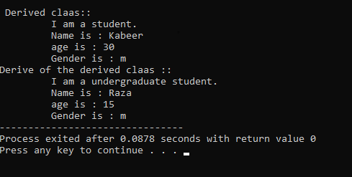

**LAB TASK No. 6**

**Task 1:**

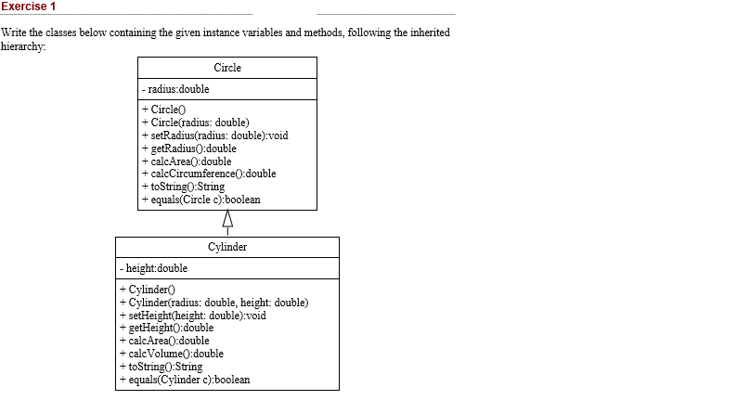

**Code:**

#include <iostream>

#include <conio.h>

#include <string.h>

#include <math.h>

#include <cmath>

using namespace std;

class circle

{

protected:

double radius;

public:

circle(double r): radius(r) { }

void setradius(double r)

{

radius=r;

}

double getradius()

{

return radius ;

}

double Area()

{

return 3.14 * pow(radius,2);

}

double circumference()

{

return 2 * 3.14 * radius;

}

void toSring(double a,double c)

{

cout<<"\n\t circle info ";

cout<<"\n circle radius :"<<radius;

cout<<"\n circle Area :"<<a;

cout<<"\n circle Circumference :"<<c;

}

};

class cylinder : public circle

{

protected:

double height;

public:

cylinder(double r,double h): radius(r), height (h) { }

void setheight(double h)

{

height=h;

}

double getheight()

{

return height ;

}

virtual double Area()

{

return ( 2 * 3.14 * radius * height) * (2 * 3.14 * pow(radius,2));

}

virtual double circumference()

{

return 3.14 * pow(radius,2) * height;

}

virtual void toSring(double a,double c)

{

cout<<"\n\t cylinder info ";

cout<<"\n cylinder height :"<<height;

cout<<"\n cylinder Area :"<<a;

cout<<"\n cylinder Circumference :"<<c;

}

};

int main()

{

circle c1(6.3);

double a= c1.Area();

double c= c1.circumference();

c1.toSring(a,c);

cylinder cc1(5.4,9.7);

double aa= cc1.Area();

double cc= cc1.circumference();

cc1.toSring(aa,cc)

return 0;

}

**Output:**

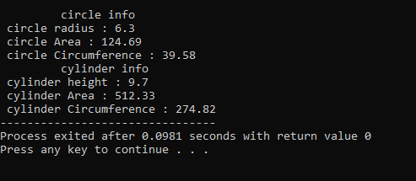

**Task 2:** Apply the Concept of Composition by Creating part classes (doors,windows,Engine,Wheels) and then Create a whole class Car that is composed of all these defined parts.

**Code:**

#include <iostream>

#include <conio.h>

#include <string.h>

#include <math.h>

#include <cmath>

using namespace std;

class windows

{

int height ;

int width ;

public:

windows(){ }

windows(int h, int b): height(h), width(b) { }

void showwindows()

{

cout<<"\n\t Windows ::";

cout<<"\n\t\t height : "<<height;

cout<<"\n\t\t width : "<<width;

}

};

class engine

{

int cc ;

int cylinder ;

public:

engine(){ }

engine(int c,int c1): cc(c) , cylinder(c1) { }

void showengine()

{

cout<<"\n\t Engine ::";

cout<<"\n\t\t Cubic Centimetres is : "<<cc<<"cc";

cout<<"\n\t\t Cylinders it contains : "<<cylinder;

}

};

class doors

{

int height ;

int width ;

public:

doors(){ }

doors(int h, int b): height(h), width(b) { }

void showdoors()

{

cout<<"\n\t Doors ::";

cout<<"\n\t\t height : "<<height;

cout<<"\n\t\t width : "<<width;

}

};

class wheels

{

double radius ; string cmname ;

public:

wheels(){ }

wheels(double r, string name): radius(r), cmname(name) { }

void showwheels()

{

cout<<"\n\t Wheels ::";

cout<<"\n\t\t company name is : "<<cmname;

cout<<"\n\t\t radius of a wheel is : "<<radius;

}

};

class Car{

engine eng; windows win; doors dr; wheels whe;

public:

Car(engine e, windows w, doors d, wheels w1): eng(e),win(w),dr(d), whe(w1) { }

void showinfo()

{

cout<<"Car Complete info";

eng.showengine();

win.showwindows();

dr.showdoors();

whe.showwheels();

}

};

int main(){

engine e(1200,6);

windows w(10,4);

doors d(15,10);

wheels wh(13,"Servis");

Car ccc(e,w,d,wh);

ccc.showinfo();

return 0;}

**Output:**

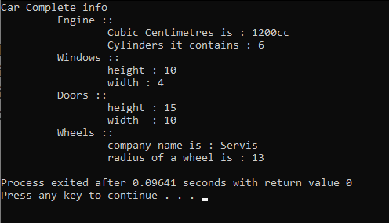

**Task 3:** Create Box class containing data members (width ,height,Length) and Member functions showdata and Volume.. Apple the concept of Operator Overloading and overload operators (+,-,* ,/) for addition subtraction multiplication and division of Objects of Box class.

**Code:**

#include <iostream>

#include <conio.h>

#include <string.h>

#include <math.h>

#include <cmath>

using namespace std;

class Box

{

int height;

int width;

int length;

public:

Box(){};

Box(int h, int w, int l) : height(h), width(w), length(l){};

int getheight()

{

return height;

}

void setheight(int h)

{

height = h;

}

int getwidth()

{

return width;

}

void setwidth(int w)

{

width = w;

}

int getlength()

{

return length;

}

void setlength(int l)

{

length = l;

}

int volume()

{

return height * length * width;

}

Box operator*(const Box b)

{

Box box;

box.height = this->height * b.height;

box.width = this->width * b.width;

box.length = this->length * b.length;

return box;

}

Box operator+(const Box b)

{

Box box;

box.height = this->height + b.height;

box.width = this->width + b.width;

box.length = this->length + b.length;

return box;

}

Box operator/(const Box b)

{

Box box;

box.height = this->height / b.height;

box.width = this->width / b.width;

box.length = this->length / b.length;

return box;

}

Box operator-(const Box &b)

{

Box box;

box.height = this->height - box.height;

box.width = this->width - box.width;

box.length = this->length - box.length;

return box;

}

};

int main()

{

Box b1(4,6,8);

Box b2(1,5,7);

Box b3;

b3=b1+b2;

cout<<"\tBox 3 dimensions"<<endl;

cout<<"Height : "<<b3.getheight()<<" Length : "<<b3.getlength()<<" width : "<< b3.getwidth();

cout<<endl<<"Box 1 volume : "<<b1.volume();

cout<<endl<<"Box 2 volume : "<<b2.volume();

cout<<endl<<"Box 3 volume : "<<b3.volume();

return 0;

}

**Output:**

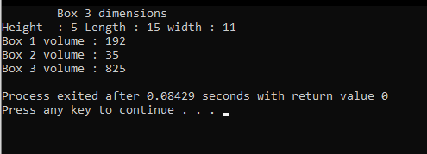

**LAB TASK No. 7**

**Task 1:** Create a Calculator class that offers four methods. Add, subtract, multiply and Divide. Consisting of two private members of type double to take input from the user. Create object of a class and start using the calculator class.

**Code:**

using System;

using System.Collections.Generic;

using System.ComponentModel;

using System.Data;

using System.Drawing;

using System.Linq;

using System.Text;

using System.Threading.Tasks;

using System.Windows.Forms;

namespace WindowsFormsApp4

{

public partial class Form1 : Form

{

class calculator

{

private int num1;

private int num2;

public calculator() { }

public int add(int n, int n2)

{

return n + n2;

}

public int subs(int n, int n2)

{

return n - n2;

}

public int prod(int n, int n2)

{

return n * n2;

}

public int div(int n, int n2)

{

return n / n2;

}

}

public Form1()

{

InitializeComponent();

}

private void Form1_Load(object sender, EventArgs e)

{

label1.Text = "Output";

}

private void button4_Click(object sender, EventArgs e)

{

int n1;

int n2;

calculator c = new calculator();

bool num1 = int.TryParse(textBox1.Text, out n1);

bool num2 = int.TryParse(textBox2.Text, out n2);

int result = c.add(n1, n2);

label1.Text = "Sum is " + result;

}

private void button1_Click(object sender, EventArgs e)

{

int n1;

int n2;

calculator c = new calculator();

bool num1 = int.TryParse(textBox1.Text, out n1);

bool num2 = int.TryParse(textBox2.Text, out n2);

int result = c.subs(n1, n2);

label1.Text ="Subtraction is " + result;

}

private void button3_Click(object sender, EventArgs e)

{

int n1;

int n2;

calculator c = new calculator();

bool num1 = int.TryParse(textBox1.Text, out n1);

bool num2 = int.TryParse(textBox2.Text, out n2);

int result = c.prod(n1, n2);

label1.Text = "Product is " + result;

}

private void button2_Click(object sender, EventArgs e)

{

int n1;

int n2;

calculator c = new calculator();

bool num1 = int.TryParse(textBox1.Text, out n1);

bool num2 = int.TryParse(textBox2.Text, out n2);

int result = c.div(n1, n2);

label1.Text = "Division is " + result;

}

private void button5_Click(object sender, EventArgs e)

{

MessageBox.Show(label1.Text);

}

}

}

**Output:**

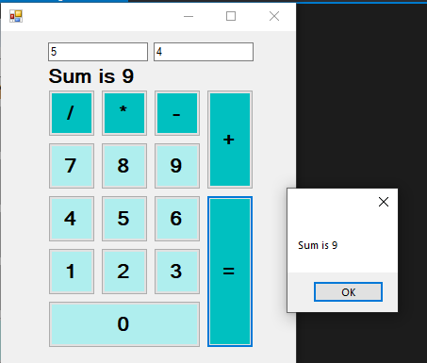

**LAB TASK No. 8**

**Task 1:**

Create a simple C# that will place one combo box filled with the names of different shapes by using item property of combo box and application should be able to draw the selected shape of combo box control by creating graphic ,pen and solid brush objects.

**Code:**

using System;

using System.Drawing;

using System.Windows.Forms;

namespace WindowsFormsApp3

{

public partial class Form1 : Form

{

public Form1()

{

InitializeComponent();

}

private void comboBox1_SelectedIndexChanged(object sender, EventArgs e)

{

Graphics g = base.CreateGraphics();

Pen p = new Pen(Color.Black);

SolidBrush sb = new SolidBrush(Color.Aqua);

g.Clear(Color.White);

switch(comboBox1.SelectedIndex)

{

case 0:

g.FillRectangle(sb, 350, 150, 200, 200);

break;

case 1:

g.DrawRectangle(p, 350, 150, 200, 200);

break;

case 2:

g.FillEllipse(sb, 350, 150, 200, 200);

break;

case 3:

g.DrawEllipse(p, 350, 150, 200, 200);

break;

case 4:

g.FillRectangle(sb, 350, 150, 400,200);

break;

case 5:

g.DrawRectangle(p, 350, 150, 400, 200);

break;

}

}

}

}

**Design:**

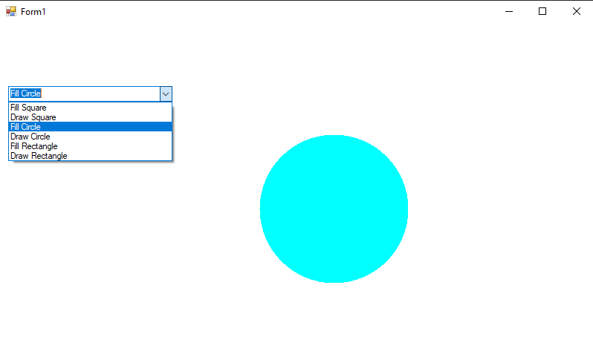

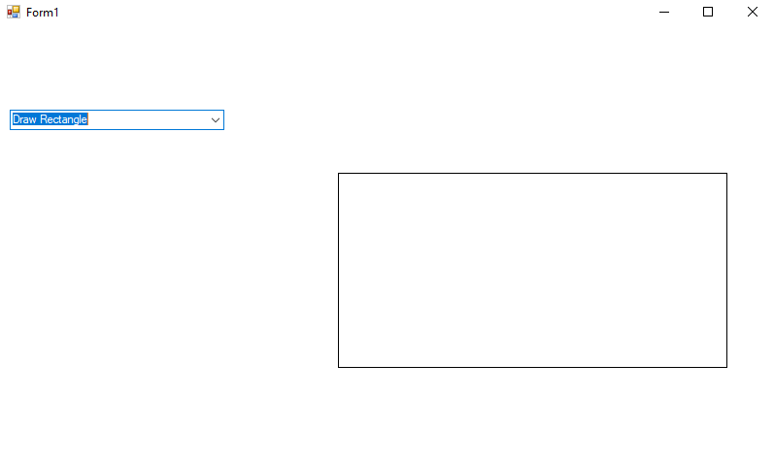

**Task 2:**

Create an array of Buttons that would display buttons dynamically at run time.

**Code:**

using System;

using System.Collections.Generic;

using System.ComponentModel;

using System.Data;

using System.Drawing;

using System.Linq;

using System.Text;

using System.Threading.Tasks;

using System.Windows.Forms;

namespace WindowsFormsApp3

{

public partial class Form1 : Form

{

public Form1()

{

InitializeComponent();

}

private void Form1_Load(object sender, EventArgs e)

{

Button[] b = new Button[10];

for (int i = 0; i <= b.Length - 1; i++)

{

b[i] = new Button();

b[i].Text = "";

b[i].Size = new Size(318 - 35 * i, 23);

b[i].Location = new Point(200 + 18 * i, 250 - 20 * i);

b[i].BackColor = System.Drawing.Color.SaddleBrown;

this.Controls.Add(b[i]);

}

}

}

}

**Design:**

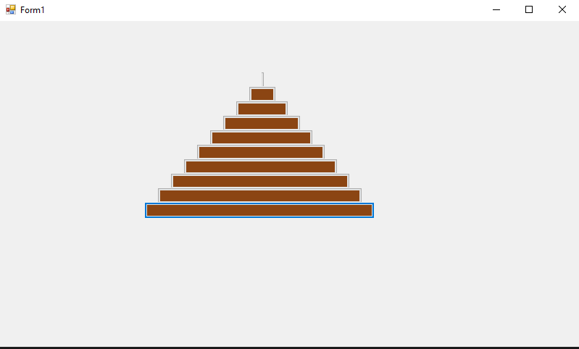

**Task 3:**

Create a slideshow of pictures by using picture box control and timer control. Make a folder on any drive containing all of your pictures, you want to include in a slideshow. Rename all the pictures starting with 1.jpg, 2.jpg… n.jpg.

**Code:**

using System;

using System.Windows.Forms;

namespace WindowsFormsApp3

{

public partial class Form1 : Form

{

public Form1()

{

InitializeComponent();

}

private void Form1_Load(object sender, EventArgs e)

{

}

int count = 0;

private void timer1_Tick(object sender, EventArgs e)

{

if(count==10)

{

count = 1;

}

pictureBox1.ImageLocation = string.Format(@"g:/slideshow/{0}.jpg", count);

count++;

}

}

}

**Design:**

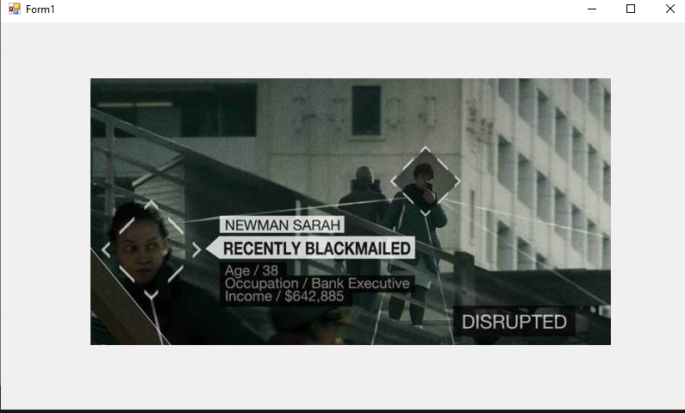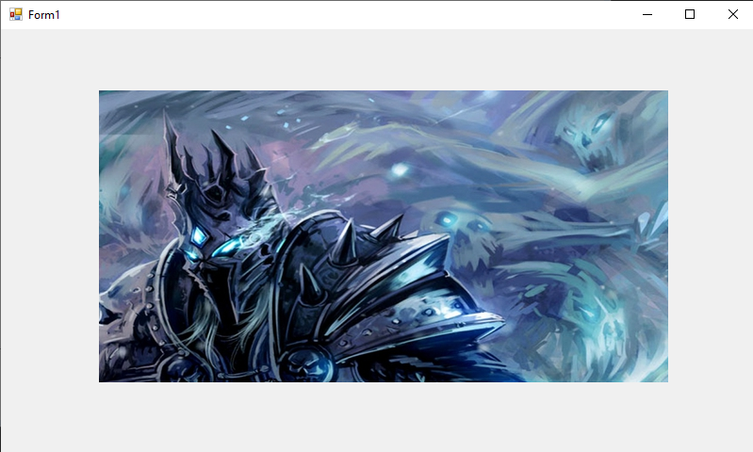

**Task 4:**

Using Mouse up, down and Mouse move events, create an application that can draw freehand drawing.

**Code:**

using System;

using System.Drawing;

using System.Windows.Forms;

namespace WindowsFormsApp3

{

public partial class Form1 : Form

{

bool isMouseDown = false;

public Form1()

{

InitializeComponent();

}

private void Form1_Load(object sender, EventArgs e)

{

}

private void Form1_MouseUp(object sender, MouseEventArgs e)

{

isMouseDown = false;

}

private void Form1_MouseMove(object sender, MouseEventArgs e)

{

if (isMouseDown == true)

{

Graphics g = CreateGraphics();

Pen p = new Pen(Color.Red);

g.DrawRectangle(p, e.X, e.Y, 10, 10);

}

}

private void Form1_MouseDown(object sender, MouseEventArgs e)

{

isMouseDown = true;

}

}

}

**Design:**

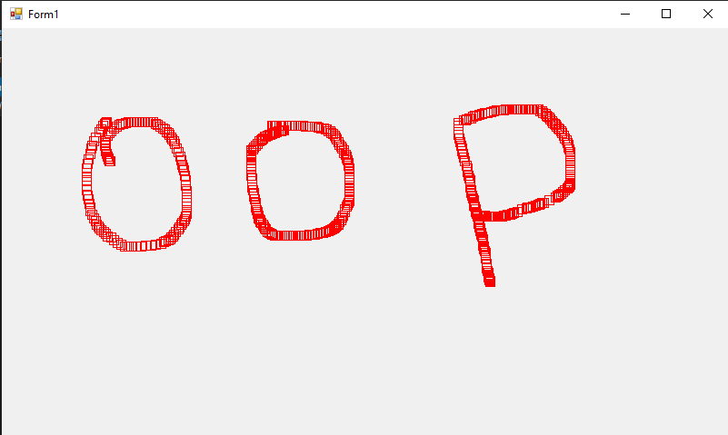

**LAB TASK No. 9**

**Task 1:**

**Code:**

using System;

using System.Collections.Generic;

using System.ComponentModel;

using System.Data;

using System.Drawing;

using System.Linq;

using System.Text;

using System.Threading.Tasks;

using System.Windows.Forms;

using System.Data.OleDb;

namespace Accessatabase2

{

public partial class Form1 : Form

{

public Form1()

{

InitializeComponent();

}

int counter = 0;

OleDbConnection co = new OleDbConnection(@"Provider=Microsoft.ACE.OLEDB.12.0 Source = E:\bank.accdb");

OleDbDataAdapter dp = new OleDbDataAdapter("select * from Account", @"Provider=Microsoft.ACE.OLEDB.12.0;Data Source = E:\bank.accdb")

DataSet dt = new DataSet("Account");

private void Form1_Load(object sender, EventArgs e)

{

this.accountTableAdapter.Fill(this.dataSet1.Account);

co.Open();

dp.Fill(dt);

}

private void button1_Click(object sender, EventArgs e)

{

if (counter < dt.Tables["Account"].Rows.Count - 1)

{

counter = counter + 1;

textBox1.Text = dt.Tables["Account"].Rows[counter]["AccID"].ToString();

textBox2.Text = dt.Tables["Account"].Rows[counter]["name"].ToString();

textBox3.Text = dt.Tables["Account"].Rows[counter]["branchcode"].ToString();

textBox4.Text = dt.Tables["Account"].Rows[counter]["Balance"].ToString();

}

else if (counter <= dt.Tables["Account"].Rows.Count - 1)

{

MessageBox.Show("You have already account");

}

}

private void button2_Click(object sender, EventArgs e)

{

if (counter > 0)

{

counter = counter - 1;

textBox1.Text = dt.Tables["Account"].Rows[counter]["AccountNo"].ToString();

textBox2.Text = dt.Tables["Account"].Rows[counter]["Name"].ToString();

textBox3.Text = dt.Tables["Account"].Rows[counter]["Balance"].ToString();

textBox4.Text = dt.Tables["Account"].Rows[counter]["Branch"].ToString();

}

else if (counter == 0)

{

MessageBox.Show("You have already an account");

}

}

private void button4_Click(object sender, EventArgs e)

{

OleDbCommand udp = new OleDbCommand("Update Account set Balance='" + textBox4.Text + "' where AccID='" + textBox1.Text +"'", co);

udp.ExecuteNonQuery();

MessageBox.Show(" Account has been updated");

}

private void button3_Click(object sender, EventArgs e)

{

OleDbCommand ins = new OleDbCommand("Insert into Account(AccID,name, branchcode, Balance) values('" + textBox1.Text + "','" + textBox2.Text + "','" + textBox3.Text + "','" + textBox4.Text + "')", co);

ins.ExecuteNonQuery();

MessageBox.Show(" Account has been Added");

}

private void button6_Click(object sender, EventArgs e)

{

this.Close();

}

}

}

**Output:**



